How Data Tells the Story: What Customers Analysis Reveal About Churn, Behaviour & Revenue
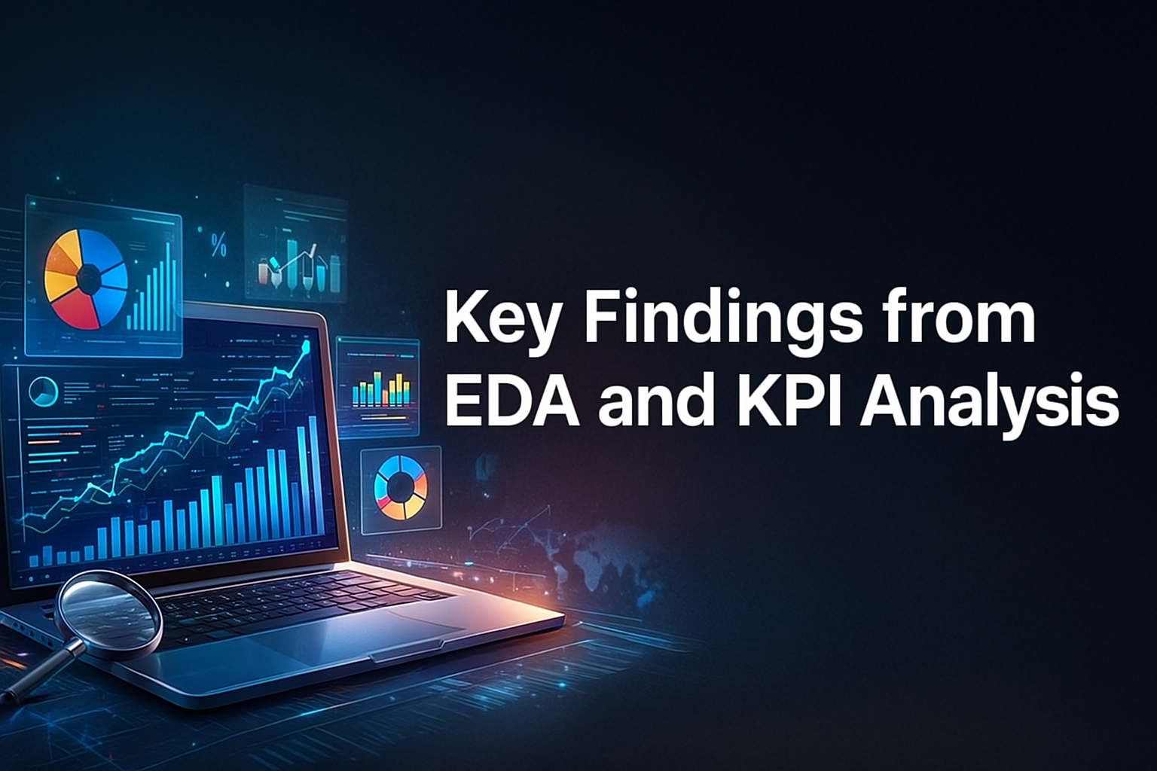
Customer churn isn’t just a number—it’s a pulse check on how well a business understands, serves, and retains its customers. When we analyzed a dataset of 6,418 telecom customers across 32 attributes, a fascinating story emerged: who stays, who leaves, and—most importantly—why.
This blog breaks down the essential patterns, KPIs, and actionable insights uncovered through the EDA (Exploratory Data Analysis) and churn segmentation study.

The Data Behind the Decisions
Before diving into insights, we ensured the dataset was clean and ready for analysis. Many service-related fields (such as Online Security or Internet Type) were missing—but only when the customer didn’t subscribe to Internet service. Since this was logical absence, we imputed them with “No service.”
Result? No critical gaps, no bias. The dataset is reliable for deep analysis.

Who Are the Customers?
This customer base is remarkably balanced and diverse:
- Gender: A near 50/50 split
- Age: Strong right-skew, median age ~40
- Tenure: Average stay of 29 months, but with many new customers still in early months
This mix already hints at churn dynamics—newer customers typically churn faster.
What Services Are They Using?
Telecom services show familiar but meaningful adoption patterns:
- 78% use Internet services, and among them:
  - Fiber Optic dominates (55%)
  - DSL follows at 30%
  - Cable trails at 15%
- 69% have phone service, with 31% using multiple lines
Higher adoption means more upsell opportunities—but also more points of dissatisfaction if service quality slips.
Churn at a Glance
The overall churn rate stands at 27%, meaning 1,732 customers left over the observed period.
When we dug into customer-reported reasons for leaving, four main themes dominated:
Churn Reason | % of Respondents
Competitor offerings | ~43%
Product / Network issues | ~35%
Price sensitivity | ~11%
Customer attitude / Other | ~11%
Key takeaway: Competition and service dissatisfaction cause nearly 80% of all voluntary churn.

KPI Deep Dive: Where the Real Gaps Exist
Here’s where the picture gets clearer. Different customer segments behave very differently:

Contract Type
Segment | Churn | Tenure | Monthly Charge | Lifetime Revenue
Month-to-Month | 42% | 14 mo | $70 | $1,008
1-Year | 7.2% | 35 mo | $64 | $2,208
2-Year | 5.1% | 56 mo | $59 | $3,312
The pattern is unmistakable:
Short commitments = high churn + low revenue:
Month-to-month customers churn 6–8x more than long-term contracts.

Payment Method
Electronic check users stand out with the highest churn at 45%, significantly higher than bank transfer or card users (10–12%).

Correlation Findings
- Monthly charges ↗ revenue (r ≈ 0.93)
- Tenure ↗ revenue (r ≈ 0.75)
High spenders and long-term customers drive the most value—losing them hurts disproportionately.

So What Should the Company Do?
Based on the patterns we observed, here are the data-backed recommendations:

A. Push Multi-Year Contracts
Month-to-month customers are the biggest churn risk.
- Offer loyalty points, small discounts, or exclusive perks for annual renewals.
- Bundle Internet + Phone for long-term plans to boost stickiness.

B. Fix the Electronic Check “Churn Trap”
Electronic check customers churn at almost half the user base.
Reduce friction by:
- Promoting easy autopay sign-ups
- Sending friendly reminders
- Simplifying billing transparency

C. Upsell Smartly
Fiber customers produce the highest ARPU, but still churn around 30%.
Give them the VIP treatment:
- Priority customer support
- Loyalty rewards
- Free device protection upgrades
Target less-engaged users with cross-sell campaigns for:
- Online security
- Backups
- Streaming add-ons

D. Attack Churn Root Causes
- Competitor issues: Improve pricing competitiveness and bundle value.
- Dissatisfaction: Strengthen network reliability and send proactive outage alerts.
- Price concerns: Offer mid-cycle discounts or flexible payment plans.

What's Next? Predict, Don’t React
The next evolution is to predict churn before it happens:
- Build churn prediction models using tenure, service mix, payment method, and complaints
- Trigger real-time offers to at-risk customers
- Track NPS and CSAT quarterly to evaluate impact
This combination of data + action can reduce churn by 15–20%, unlocking significant revenue growth without acquiring a single new customer.

Final Thoughts
This analysis reveals a clear story:
Churn is preventable when you know where to look.
By focusing on:
- At-risk segments
- Seamless billing
- Superior service
- Strategic contracts
- Personalized retention
…telecom companies can transform customer experience and profitability simultaneously.
The data is talking. The question is:
Is your business ready to act on it?

